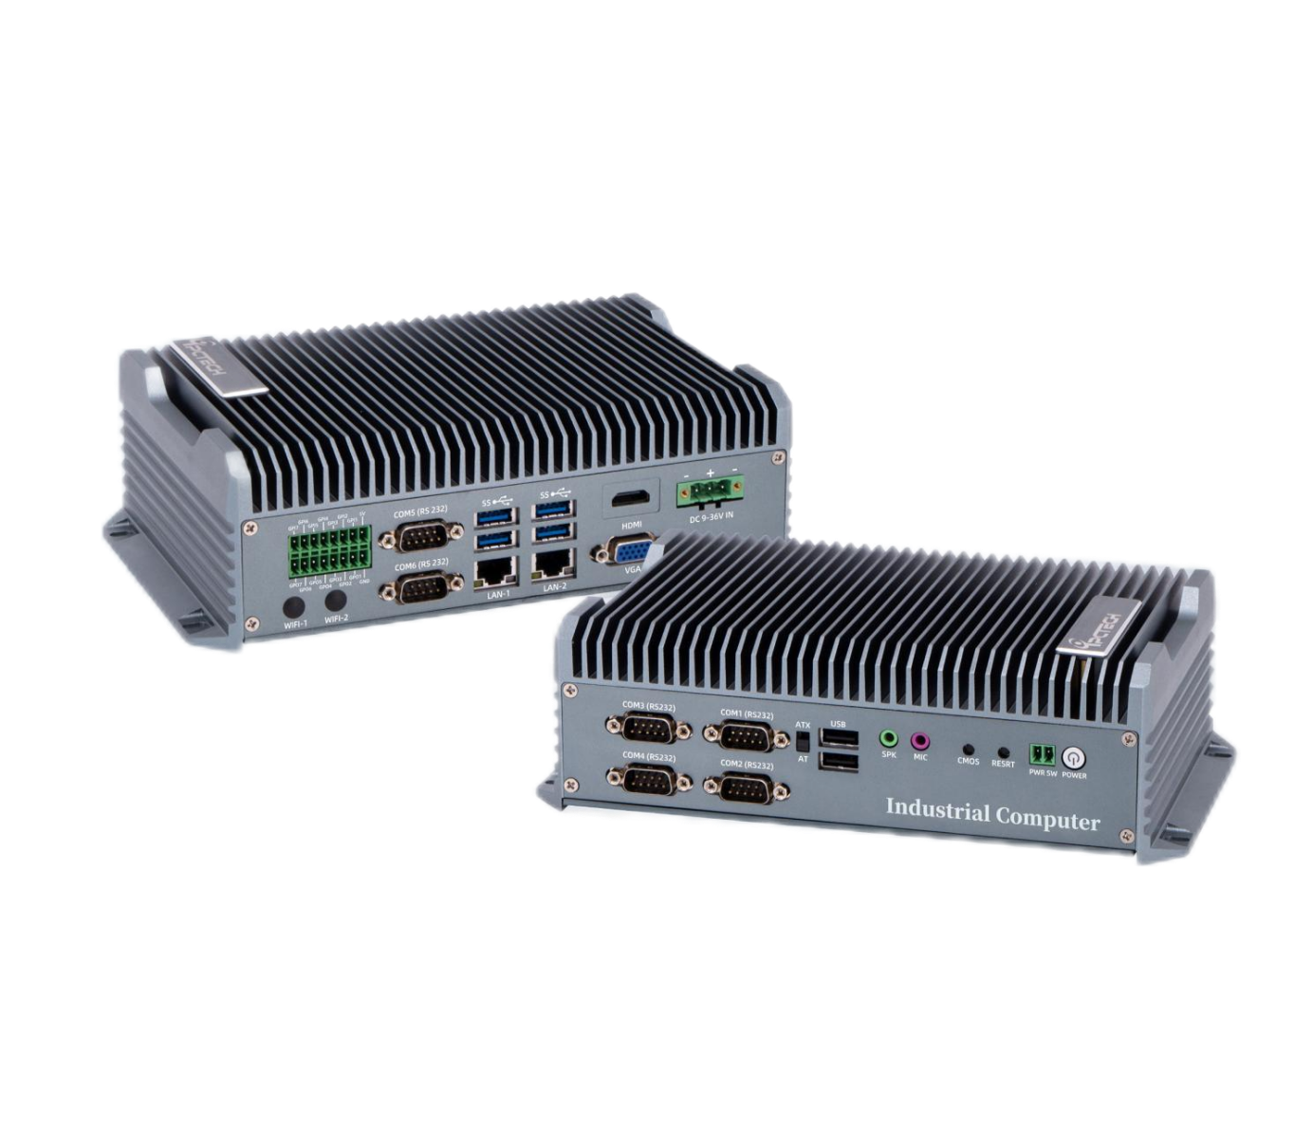
Industrial Mini PC
QY-B5000
High Performance Series

Products Features:
- Industrial-Grade Embedded Fanless Mini PC
- Intel Core 13th-i5 / i7 CPU
- 2*LAN, 6*USB, 6*COM, 1*HDMI, 1*VGA, 14*GPIO
- 2*Mini PCIE Expansion Slots, Support 4G and WIFI Module
- DC 9-36V Power Input With Overvoltage Protection
- -30℃~70℃ Temperature Can Keep 24/7 Work Stably
- Anti-Static, Anti-Pulse, Anti-Surge, Anti-Radiation
QY-B5000
1.Mother Board Specification:
Model | QY-B5000
CPU | i7-1355U
Memory^{[1]} | 2*DDR V RAM Slots, Up to 64GB
Storage | 1*MSATA SSD Slot  1*M.2 NVME SSD Slot  1*SATA SSD Slot
Display | 1*HDMI: Resolution up to 4096*2304@60Hz  1*VGA: Resolution up to 1920*1200@60Hz
Expansion | 1*Mini PCIE+1*M.2 Slots  Support 4G/5G and WIFI module
Ethernet | 2*Intel i225V LAN Chip (10 / 100 / 1000 / 2500 Mbps, RJ-45 Type)
USB | 4*USB 3.0+2*USB 2.0 (Type-A)
COM | 2*RS-232 / 422 / 485 (DB9 Type)  4*RS-232 (DB9 Type)
Audio | 1*Line-In+1*Line-Out
GPIO | 14 ports GPIO (7*GPI+7*GPO, Phoenix Terminal Type)
Notes:
[1]: The maximum memory capacity and the maximum capacity per strip supported by this motherboard depend on the CPU.

QY-B5000
2.Device Specification:
Watch Dog | Support
Power Input | DC 9-36V With Overvoltage Protection
Power Input | Support Auto-Start
Power Input | 3 Pin Phoenix Terminal Type DC Plug
Working Temperature | -30℃~70℃, Support 24/7 Working
Structure | Fully Enclosed Aluminum Alloy Material
Heat Dissipation | Fanless Design, Conduction Heat Dissipation
Installation | Desktop / Embedded / Wall Mount
Size | 236mm*157mm*72mm
System | Windows and Linux

QY-B5000
3.Ordering Information:
Model | CPU | LAN | USB | COM | Display | RAM | SSD | Expansion | Power
QY-B5000 | 13th | 2 | 6 | 4*RS-232  2*RS-232/422/485 | 1*HDMI  1*VGA | 2*DDR 5  Up to 96GB | 1*M.2 NVME  1*MSATA  1*SATA | 2*M.2 | DC 9-36V

4.CPU Information:

CPU | Specification
i7-1355U | 10 core, 12 total threads, 3.70 GHz to 5.00 GHz, 12MB cache | Max to 96GB for 2*RAM 5 Slots

CPU | System
11th/ 12th / 13th | Windows 10 / 11 and Linux
5.System Information:

QY-B5000
6.Fittings Information:
 | DDR 5 | 4GB / 8GB / 16GB / 32GB / 48GB
Storage | MSATA | 64GB / 128GB / 256GB / 512GB / 1TB
Storage | M.2 NVME | 128GB / 256GB / 512GB / 1TB / 2TB / 4TB
Storage | SATA | 120GB / 128GB / 240GB / 256GB / 480GB / 512GB / 960GB / 1TB / 2TB / 4TB
GSM Module | 4G | 4G+GPS
GSM Module | 5G | 5G+GPS
WIFI Module | 7260AC / AX210

7.Package List:

Adapter | 1*12V 7A Adapter
Power Cable | 1*Power Cable
Terminal | 2 Pin Phoenix Terminal For Power Switch
Terminal | 16 Pin phoenix terminal for GPIO

8.Dimensions:
QY-B5000

